**INTRODUCTION**

Computing designed like normal commodities like traditional utilities. In such a way that users can access like the way want and from anywhere they want. Cloud computing is a it paradigm (model) which relies on sharing of resources to reduce investment in individual setups so that companies can gain profit at an economic scale of their IT department .In cloud the end user pay for the services they choose, cutting of the extra expenses on hardware and infrastructures and the rest of the managing and security are managed by the service provider .It is a conceptual based technology which is widely used nowadays.

After the launch of EC-2 in 2006 cloud computing environment has evolved and transformed the way how companies work because now they don’t have to invest much in their IT sectors . All they have to do is , deploy a server in the cloud and use the “pay as you go” service according to their convenience.

Basically the data and definitions provided by the NIST the cloud consist of 5 characteristics, 4 deployment models and 3 types of services.

But except all the flexibility and scalability cloud computing arena faces a lot of privacy issues and challenges .There are trust problems between service providers and consumer privacy leaks ,cloud intrudes etc. But to reduce security issues many organizations have been set up such as Akamai etc to maintain the “***Quality of service***”(qos).

**HOW CLOUD IS DIFFERENT FROM OTHER MODELS ?**

Mostly clouds are confused to be a combination of cluster and grid computing. However these are just these are just next generation data centers. Including the features of both cluster and grid computing . clouds have the hardware of different grids whereas software to that of cluster.

The clouds proved to be the more flexible and scalable than other paradigms in same arena . as it is considered to be the advance level of all its companions paradigms it is more feasible from cluster and grid computing because of its main feature of mutitenancy which makes it quiet a totally different sector in which companies can earn as well as save their thousands of grands .

Cloud computing is also ahead of other paradigms as it covers a major larger area network . as for consideration cluster can be compared with LAN , grid computing with MAN and clouds as WAN . and as it is so wide that the client can use it from anywhere and on any device they want .

Through years the popularity of different paradigms have also varied as the trend measures the popularity of all the three computing environments as during 1990’s cluster computing was buzz word , from early 2000 grid computing came in light and overcoming changed networking and IT management for companies.

After the introduction of the concept of cloud computing many multinational companies launched their cloud services making currently AWS (Amazon Web Services), azure and Alibaba cloud services global leaders in it .

**CHARACTERISTICS OF CLOUD**

After examining its difference from other paradigms the cloud computing offers some of its characteristics. In which NIST layed on five of its essential characteristics-

* ***On demand self-service*** - Consumer can provision such as processing power , server time , and network without any human intervention .
* ***Broad network services*** - Clients can access the service by any thick or thin client platforms (eg-workstations, web browsers, phones , laptops etc .)
* ***Resource pooling*** ­­- This characteristics explains the concept of multi tenancy as customers shared pooled computer resources. Because the service provider’s computing resources are used to serve multiple clients . Cloud customer can specify where to store data at geographical level . but the client will have no idea about the location of the application or data storage.
* ***Rapid elasticity*** – prominent capabilities like storage network bandwidth and computer resources availed by the client can be elastically provisioned and released automatically to scale outward and inward and match the demands .The services can be applied in ant quantity at any time .
* ***Measured service***- Cloud has the leveraging metering capability that can actually that can actually measure transactions , bandwidth , active users and the utilization of resources and in addition they monitor and control of resources . and all this provides transparency for both of the service provider and client

**TYPES OF CLOUD SERVICES**

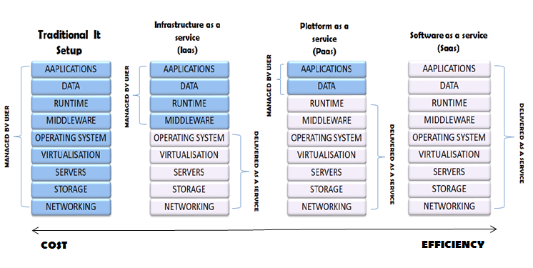

The cloud computing also provides three types of service models from which the users can choose the which ever service they want according to their requirements which are stated as follows

***Infrastructure As A Service (IAAS)***

In this service model the the server provides client with computing infrastructure which includes resources such as network , operating server , and storage using the virtual technology concept .this service highly scalable and automated computer resources. after getting provided with everything it may depend on the service provider , that they might be able to configure their networking but in more sophisticated and limited way. The biggest advantage is that the companies have the same capabiltites and technologies as their traditional data centers only the difference is that now their data centers are now “virtual data centres ” in the cloud .

* ***When we can use IAAS***

There are certain set of conditions in which each service model is used as IAAS is mostly preferred for the small companies and startups, as the startups cant invest much in their infrastructure and have to earn profits for their initial periods . it is also beneficial for the large companies which don’t want to spend their time , money and labor in trying to create their software and hardware .

***Platform As A Service(PAAS)***

Enterprise use PAAS to deploy and maintain applications while other things are observed and maintained by the service provider such as the middleware and the operating server . this delivery service gives liberty to the user for making softwares without having an eye on the other essentials such as software issues and updates ,infrastructure and the storage problems .but somewhat PAAS lacks behind from IAAS in its flexibility .

* ***When we can use PAAS***

Mostly it is more flexible and successful if there multiple workers and developers on as single projects . PAAS is generally more scalable if some other client has to be added on the same project. It is majorly profitable in cases where the apps have to be rapidly made or deployed.

***Software As A Service(SAAS)***

It is one of the most familiar delivery model and also can be called as cloud application services . this model usually uses the net services to provide its applications to its clients and these are mostly managed by the third party vendors .in this model service the clients do not need any installation on any client side as the software and applications can be accessed by the web services . and also for the ease the companies are rarely responsible for much except some of the data and configuration management .it can also be referred as “*on demand software* ” because in this the user have to only pay for the usage according to his/her requirements .

* ***When we can use SAAS***
* It can be majorly for the software and applications which aren’t used more often or which are not much in demand.
* For the enterprises which are usually in collaboration or in joint ventures for short duration.
* The utilities which both requirements of web and mobile access.

**DIFFERENT TYPES OF DEPLOYMENT MODELS**

* ***Public cloud***

When the cloud infrastructure and services are made available to a large industry or group .it provides global scale and intensive capabilities for example networks , and savings through economies. And the operations can be accomplished with more flexibility and efficiently .it is usually based on on demand pay per as use or can be free .major advantage of public cloud is that it helps to reduce cost over many things and they usually managed by the datacenters which belongs to the service providers and these use the concept of multi-tenancy which means the resources provided by the service providers is used by the multiple customers .

* ***Advantages of public cloud***
* Clients can create their own clouds if they do not want to depend on the party .
* We can access it from anywhere and from any device we want according to our ease.
* The client only have to pay for the services the client utilizes.
* ***Private cloud***

Private cloud mainly serves one particular organization but however unlike the public cloud it lacks the capability and economies of scale. as it is shared by one particular organization so there is no interference of the outsiders . so this feature makes it more secure but on the more it makes less flexible which is one of the main feature of the public clouds . but the organizations concerned about their security can be burden free as the private cloud paradigm are not to prone malicious attacks .it also uses a pay per use model To cater spikes in demand of cloud computing .

* ***Advantages of private cloud***
* as it serves only a particular organization so the organizations can modify the clouds according to their requirements .
* as the private clouds are made only for a particular organization so the security is at its level best which the other cloud deployment models lack .
* as the organizations have their own cloud systems so there is no compromise in the resources .
* ***Hybrid cloud***

The recent success of this cloud deployment model has made it the most flexible and versatile paradigm from which the enterprises are earning huge profits without investing their much revenue in IT infrastructure . as it has the features of both private and public deployment models. Hybrid clouds mix of environments of both the other models is called cloud bursting and it enables highly elastic environments . and this paradigm also offers access to data and application . hybrid clouds are nowadays the most popular service model.

* ***Advantages of hybrid cloud***
* It is more compatible as we have to only pay for the extra expenses
* Hybrid cloud is much more versatile and flexible than other two models .
* It highly profitable to organization of every size and of any sector as it has the feature of any other model .

**HOW HYBRID CLOUD EMERGED ?**

Throughout the paper we discussed about the cloud ,its characteristics ,its services ,its characteristics, services and models . but from more than half a decade there is a particular sector within cloud computing which is at its peak which has affected both the service provider and the clients. And this sector is known as “hybrid cloud ”. as the name suggests it is one of the of the deployment models but can be said as “the best of both the private and public worlds ”because the main advantage of hybrid cloud is , it provides environment which is a mix of on premises private cloud and a third party with the combination of services of orchestration between the two platforms which is a feature of public clouds. Many companies tried to draw out an algorithm to help the customer for choosing an appropriate cloud deployment model. But the outcomes were only in the favor of hybrid clouds because of its mixed environment making it the most flexible ,scalable and cost effective model. Over the years companies noticed variations in many cloud services. But they saw a common trend of growing services in hybrid clouds as shown

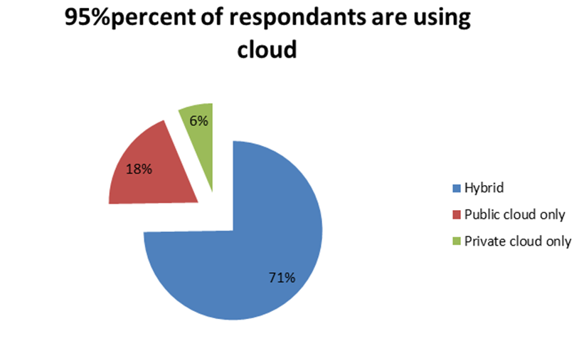

**Fig 1.2: Usage of cloud**

in fig1.2 . many companies have their individual reports of their sales growth in hybrid clouds. But moving further you will study a comparative study case study of data , client list ,revenue reports provided by the companies which are global leaders in their respective services whether it be the service provider or the clients . such as AWS ,Gartner ,Azure ,IBM , Redpixie, Alibaba and many others.

The case studies and reports released by IBM gives a rough Idea of hybrid clouds have affected then business . in table 1 are some are some of the recent success of IBM .Furthermore are the transformation study that states.

* The figures shows that 8 out of 10 leaders believe that hybrid clouds are most secure .
* Global leaders are using hybrid models because its real time analytics to manage hybrid environments.
* 62% percent of businessmen believe hybrid helps them to meet compliance requirements.

Similarly one of the multinational company REDPIXIE published a booklet according to the information and definitions provided by Gartner which clearly mentions is in upcoming years this global shift towards the cloud will affect £796 billion in it expenditure and looking at the trends and statistics this is possible only because of the investments done by companies in hybrid clouds.

Observing the other major players such as AWS (Amazon Web Services) which has earned the most through cloud computing as shown in fig(1.3) had also provided their case studies which leaves no doubt on the fact that small companies are emerging as multi nationals by saving their millions of dollars in IT structures. Because of their investments in clouds and majorly the hybrid ones. AWS`S client list also includes major players which have also deployed hybrid and today are at the top of their sectors.

Many companies have also stated that its favorable to invest in hybrid ones as it provides you the exposure to that of a public cloud in addition security, privacy of a private cloud.